### **2. INTERFACES AND CABLES**

#### **SWITCHES**

* Typically provide multiple PORTS for connectivity, usually 24.
* These PORTS are commonly RJ-45 (Registered Jack) ports.

#### **WHAT IS ETHERNET?**

* Ethernet refers to a set of network protocols and standards.

##### **Why do we need network protocols and standards?**

* To establish common communication standards across networks.
* To ensure hardware compatibility and connectivity between devices.

##### **Connection Speeds**

* Device connections operate at defined speeds, measured in "bits per second" (bps).
* A **bit** is a value of "0" or "1," while a **byte** equals 8 bits.

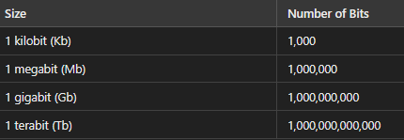

##### **Ethernet Standards**

* Defined by the IEEE 802.3 standard in 1983.
* IEEE stands for **Institute of Electrical and Electronics Engineers**.

#### **ETHERNET STANDARDS (COPPER)**

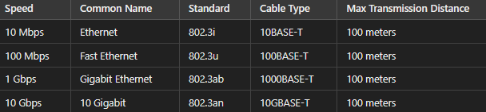

* **BASE**: Indicates Baseband Signaling.
* **T**: Refers to Twisted Pair cabling.

##### **UTP (Unshielded Twisted Pair)**

* Commonly used copper cable.
* Does not include a metallic shield.
* Twisted design protects against **EMI (Electromagnetic Interference)**.
* Usually contains 8 wires (4 pairs), but some standards use fewer wires:
  + **10/100BASE-T** uses 2 pairs (4 wires).

#### **DEVICE COMMUNICATION VIA CONNECTIONS**

##### **RJ-45 Pins**

* Ethernet cables have RJ-45 plugs with 8 pins.

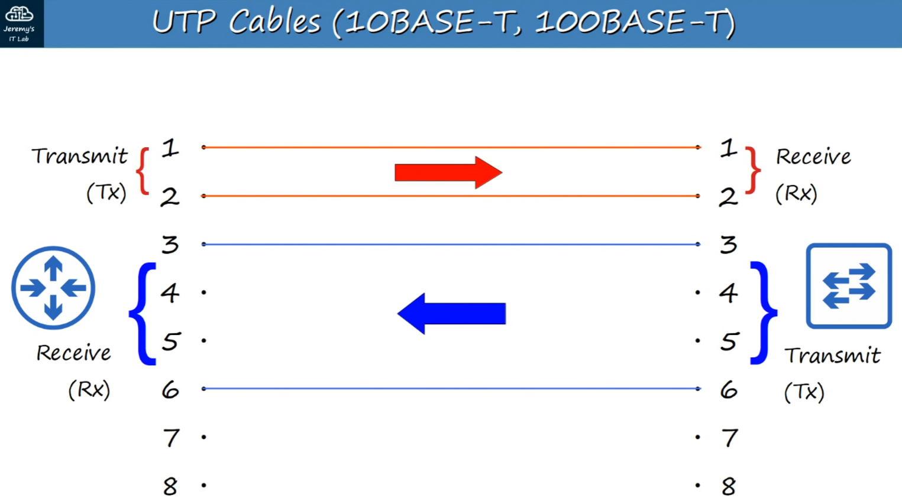

This configuration allows for **Full-Duplex** data transmission.

##### **Connecting Similar Devices**

* For connections between similar devices (e.g., Router to Router), a **Crossover Cable** is required.
* Crossover cables swap the pin assignments:
  + PIN#1 → PIN#3
  + PIN#2 → PIN#6
  + PIN#3 → PIN#1
  + PIN#6 → PIN#2

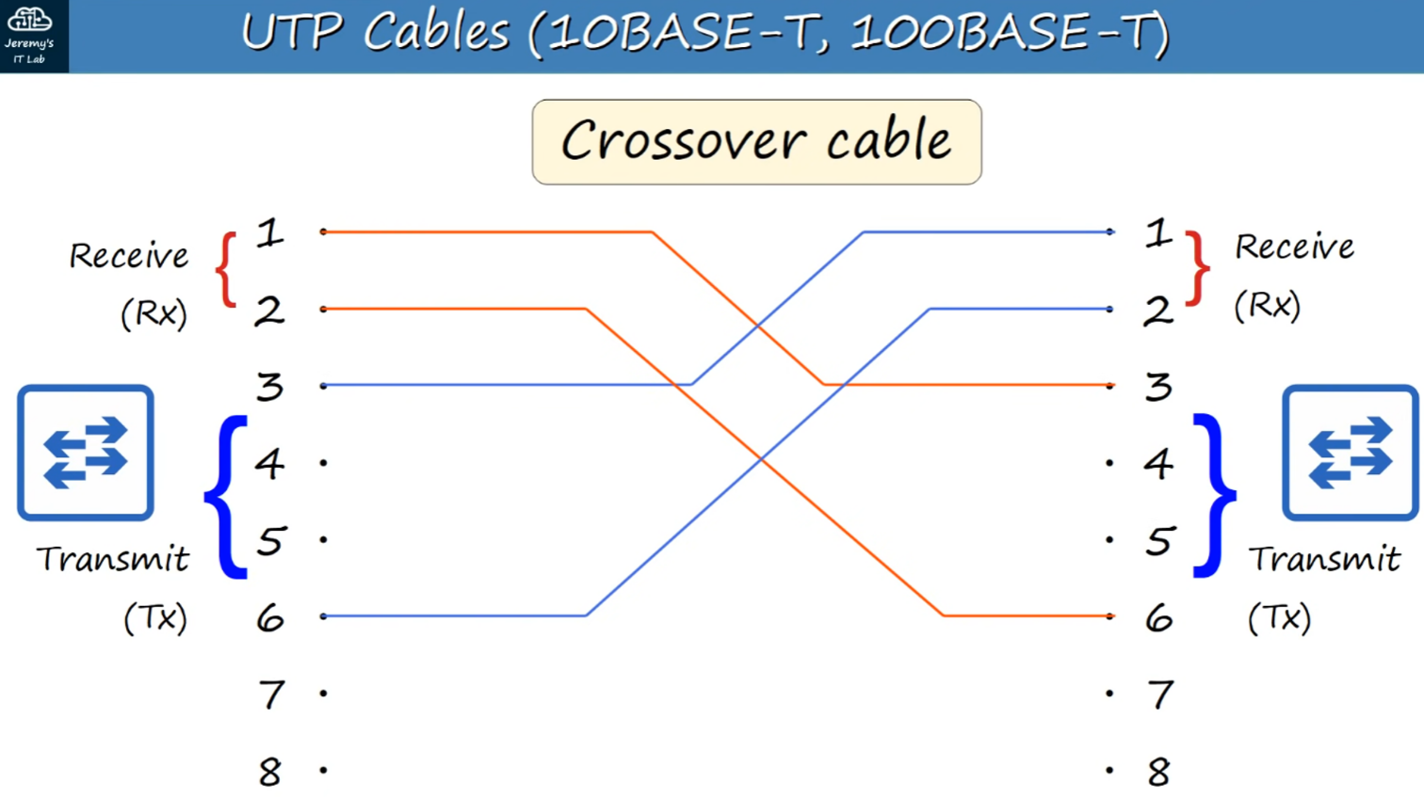

##### **Modern Equipment**

* Most modern devices support **AUTO MDI-X**, which automatically adjusts pins for compatibility, removing the need for crossover cables.

##### **Higher Speed Standards (1000BASE-T/10GBASE-T)**

* Use 4 pairs (8 wires) where each wire pair is bidirectional, allowing faster transmission compared to 10/100BASE-T.

#### **FIBER-OPTIC CONNECTIONS**

* Governed by the IEEE 802.3ae standard.
* SFP (Small Form-Factor Pluggable) transceivers enable fiber-optic cables to connect to switches or routers.
* Fiber-optic cables use separate lines for transmitting and receiving.

##### **Types of Fiber-Optic Cables**

1. **Single-Mode Fiber**:
   * Narrower core for laser-based transmission.
   * Supports longer distances than UTP or multimode.
   * More expensive due to laser-based SFP transmitters.
2. **Multimode Fiber**:
   * Wider core for LED-based transmission.
   * Supports multiple light wave angles (modes).
   * Cheaper but shorter distance compared to single-mode.

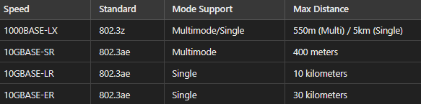

#### **UTP vs Fiber-Optic**

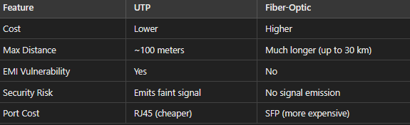a